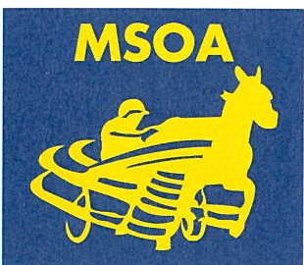
MEADOWS STANDARDBRED OWNERS ASSOCIATION
"Horsemen Helping Horsemen"

FOR IMMEDIATE RELEASE
CONTACT: Evan Pattak, 412.401.5393, pohla@aol.com

JEFFERY P WINS 3RD STRAIGHT, 14TH THIS YEAR AT THE MEADOWS

By Evan Pattak For The Meadows Standardbred Owners Association

WASHINGTON, PA, Nov. 17, 2021 — Jeffery P abandoned the pocket into the final turn, blew past his stablemate, Perlucky, and rolled to his third straight victory in Wednesday’s $17,600 Open Handicap Trot at Hollywood Casino at The Meadows.

Jeffery P was content to sit second for the middle half, but when Dave Palone asked him for trot, the 6-year-old Full Count-Betty Jean gelding instantly accelerated and scored by 2 lengths in 1:53.1. King Alphonso in the Lightning Lane and the first-over Just Like Magic completed the ticket.

Jeffery P triumphed for the 14th time this year and lifted his career bankroll to $354,761. Ron Burke trains him for Burke Racing Stable, Weaver Bruscemi LLC and Phillip Collura.

Elsewhere on Wednesday’s card, Bettor Lady exploited a cover trip to extend her winning streak to seven in an $8,400 Filly & Mare Claiming Handicap Pace. The 7-year-old daughter of Bettor’s Delight-Badlands Iron Lady prevailed for Ridge Warren and owner/trainer Santiago Porfilio.

Burke collected three wins on the 12-race card, Ronnie Wrenn, Jr. fashioned a double and Bryce Brocklehurst enjoyed both a driving win and a training victory.

Live racing at The Meadows continues Thursday when the 12-race program features a $5,175.28 carryover in the final-race Super Hi-5. First post is 12:45 PM.

EDITORS: Attached is a finish-line jpg of Jeffery P winning Wednesday’s feature at The Meadows.
-30-

The Meadows Standardbred Owners Association (MSOA) is a nonproft oganization that represents the interests of approximately 700 Standardbred trainers, drivers, caretakers and owners at The Meadows. In addition to providing horses to race at The Meadows, MSOA administers such member-centric services as health insurance and retirement programs for horsemen and horsewomen.

P.O . Box 253 • Meadow Lands, PA 15347
724-228-3644 • Fax: 724-228-5047 • msoa@themsoa.com

